317 – Phase III Access FAQ

## Where to get Access

Microsoft Access is only available on for Windows Operating Systems. Office for Mac does not come with Access, but you can install it if you are running Windows virtually with something like VMWare or Bootcamp. You can download a free trail 60-day of Microsoft Office 2010 (which includes Access) here.

<http://office.microsoft.com/en-us/access/>  
  
If you do want to buy Access, make sure you buy an Office bundle that has it; not all of them include Access.  You can get discounts through Northwestern and from Microsoft with your .edu email.    
  
$70.50 - <http://northwestern.onthehub.com/>  
$99.95 - <http://www.microsoftstore.com/store/msstore/pd/productID.229301900>

## Where to get Access tips

Microsoft’s website is a great source to get help and tips. Some of their tips are for older versions of Access (even as old as 2002) so they may look very different, but the concepts are usually the same.

YouTube is also a great place to get tips. Just make sure to include what version of Access and what you are looking for when you search.

<http://office.microsoft.com/en-us/access-help/>

<http://www.youtube.com/>

## 1:1 Relationships

Your Primary Key should always have the property **Indexed=Yes (No Duplicates)**.  Primary Keys are by definition unique, so they can't allow duplicates.  
  
In order to create a 1:1 relationship, the Foreign Key should also have the property **Indexed=Yes (No Duplicates)**.

## Combo Boxes

* Open the child table (BookAuthor). Click on the attribute that is the foreign key (bookID). In Field Properties click the Lookup tab.

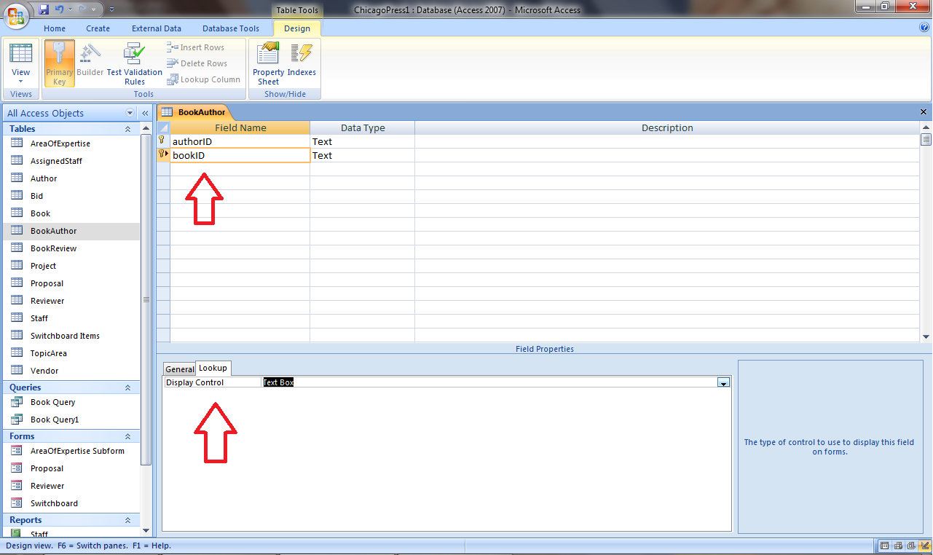

* Choose Display Control = Combo Box.
* Choose Row Source Type = Table/Query.
* Choose Row Source =Book [Parent Table].

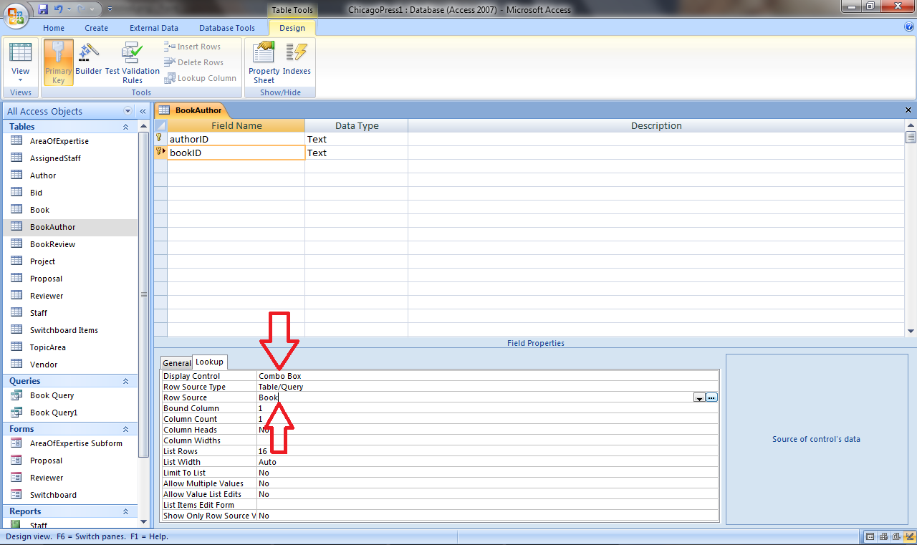

## Report that accepts a Parameter

There are many ways to create a report. The Report Wizard allows you to choose whether you want to add columns from a table or a query. In order to create a report that accepts a parameter, you must first create a query that accepts a parameter.

To create a query that accepts a parameter, you must enter the instructions you want to display to the user in square brackets under the CRITERIA section of the Query Wizard.

Now just choose to pull data from this query when creating a report.

For example:

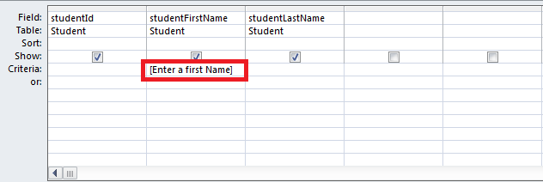

## To open the Switchboard Manager in Access 2010:

Step 1:

1. Choose **More Commands** from the **Customize Quick Access Toolbar** menu.

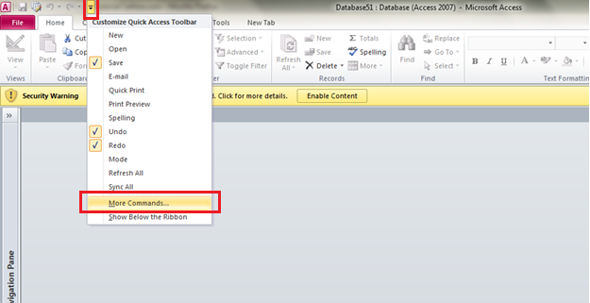

## To open the Switchboard Manager in Access 2010 *(cont’d):*

Step 2:

1. Change **Choose commands from** drop-down list to **All Commands**.
2. Find **Switchboard Manager** in the list and click on it to select it.
3. Click the **Add** button to add it to the quick access list.

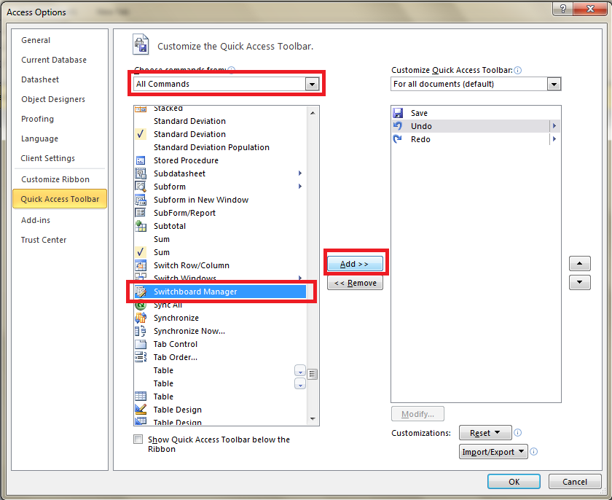

Step 3:

1. The button to open the **Switchboard Manager** is now located on the **Quick Access Toolbar**.
2. Click on it to open the **Switchboard Manager**.

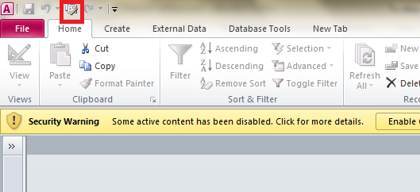

## Switchboard Manager Summary:

The switchboard manager has two main dialog boxes: The Switchboard Manager page and the Edit Switchboard page.  
  
The Switchboard Manager is the first box that launches when you launch the Switchboard Manager.  This is where you create switchboards and edit their properties (name and position on the page).

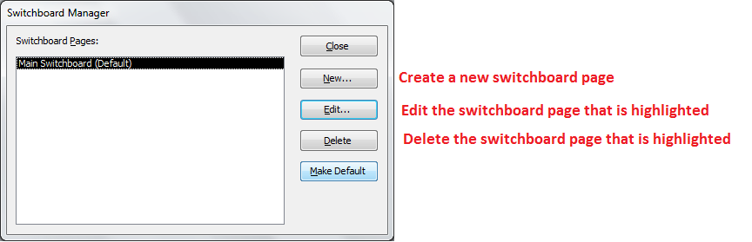

If you select a switchboard and press Edit, it takes you to the Edit Switchboard page.  This is where you edit the buttons on a specific switchboard.

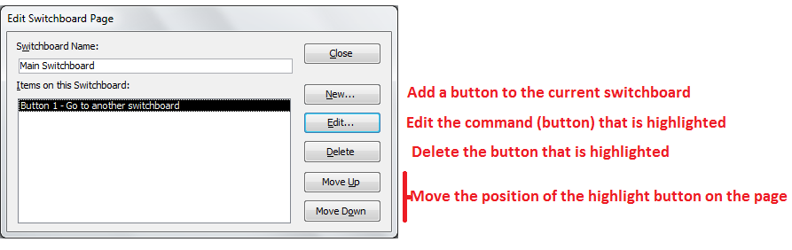

## Display switchboard when open database

* Click the **Microsoft Office Button** Button image
* Click **Access Options**.
* Click **Current Database**.
* Select **Switchboard** from the **Display Form** drop-down list.
* Click **OK**.
* Close the database and reopen it.
* The switchboard opens automatically

## Password Protect

* SAVE A BACKUP BEFORE PASSWORD PROTECTING!!!
* In order to add security to the database you must open it exclusively. To do this, make sure it is closed.
* Go to File 🡪 Open

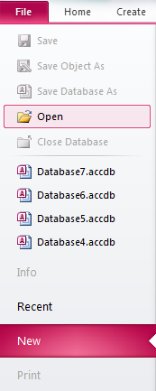

## Password Protect *(cont’d)*

* Highlight your file.
* Click the arrow next to Open.
* Choose Open Exclusively.

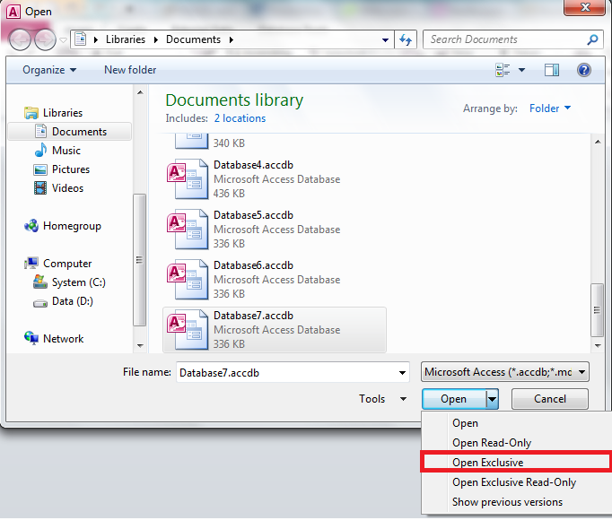

## Password Protect *(cont’d)*

* Navigate to the *File* tab again.
* Click on *Encrypt with Password*.

